**Lab: Cloudfront Distribution Creation**

**Services Used: S3, Cloudfront**

1. Verify cloudfront distribution deployed and enabled.

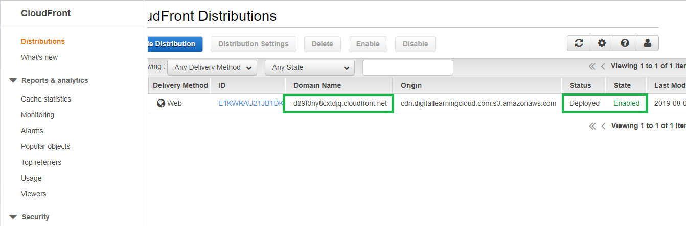

1. Check the cloudfront distribution’s accessibility and it is working fine.

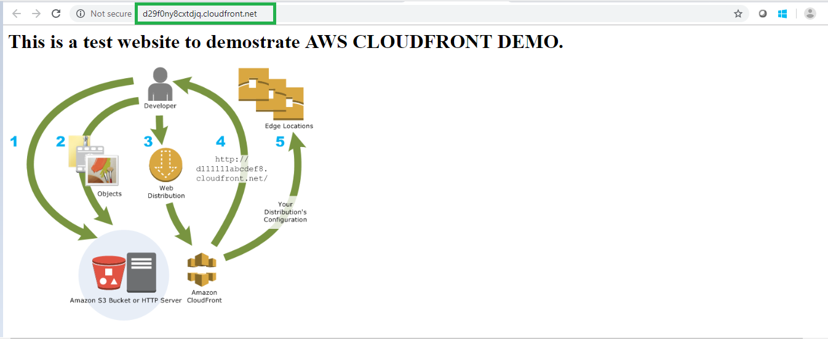

1. Click the viewers tab in the cloudfront dashboard and select locations tab. Here we can see the top locations based requests received which we can evaluate and block if any location that is required.

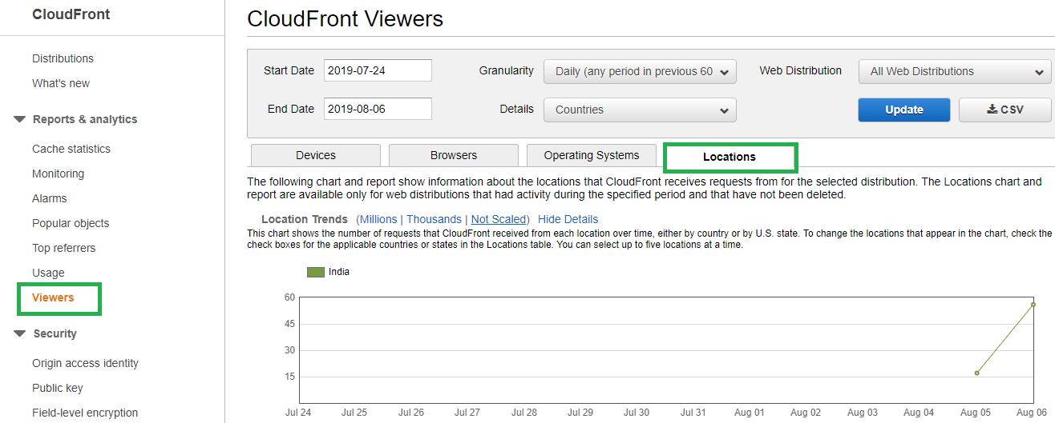

1. In this example we care going to impose restriction by blocking requests originating from India location by blacklisting.
2. Click the distribution that you want to restrict and select the restrictions tab. Currently the geo restriction is disabled. Click edit to enable it.

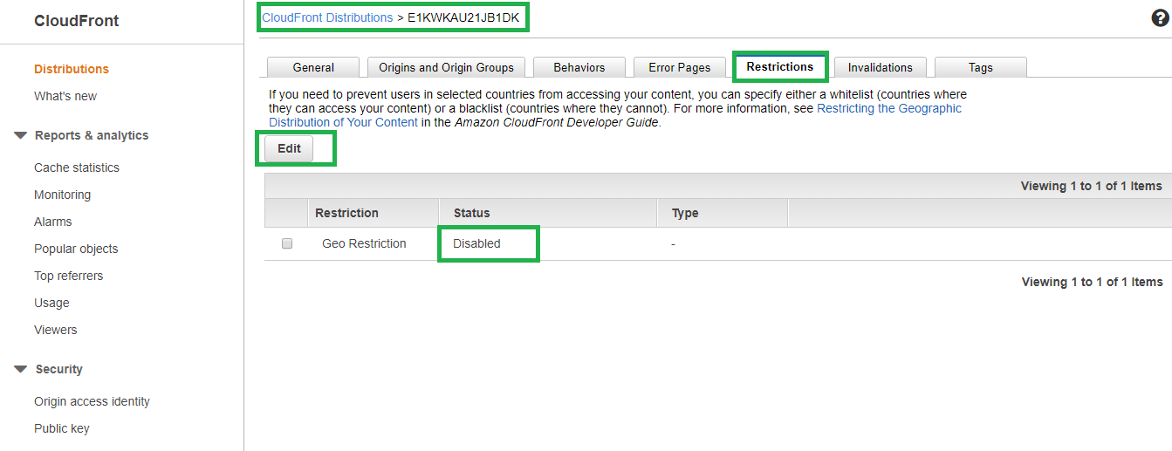

1. In the Geo-Restriction settings enable the restriction and select blacklist and countries as India and Edit.

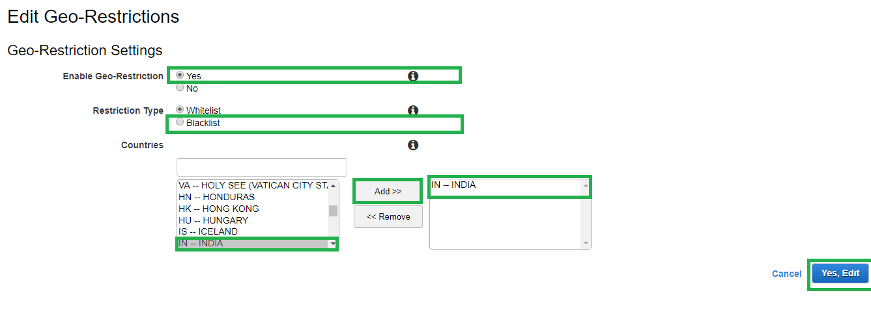

1. Now Geo Restriction is enabled and India location is blacklisted which makes requests originating from India should be blocked accessing the cloud front distribution.

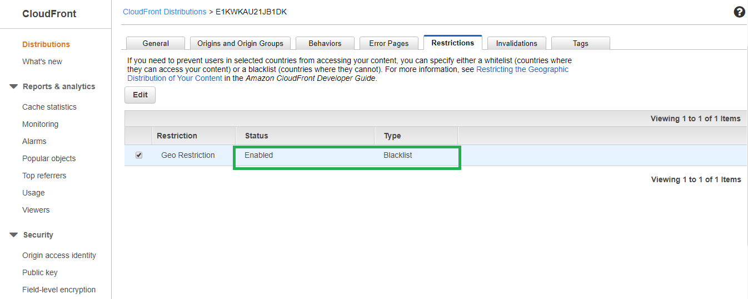

1. Try accessing and see the access denied error as below.

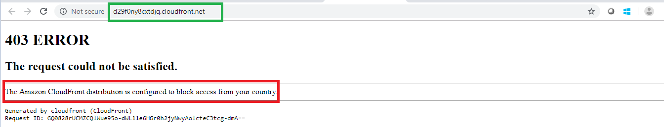

1. The other way to do geo restriction is by white listing certain locations only using below method.

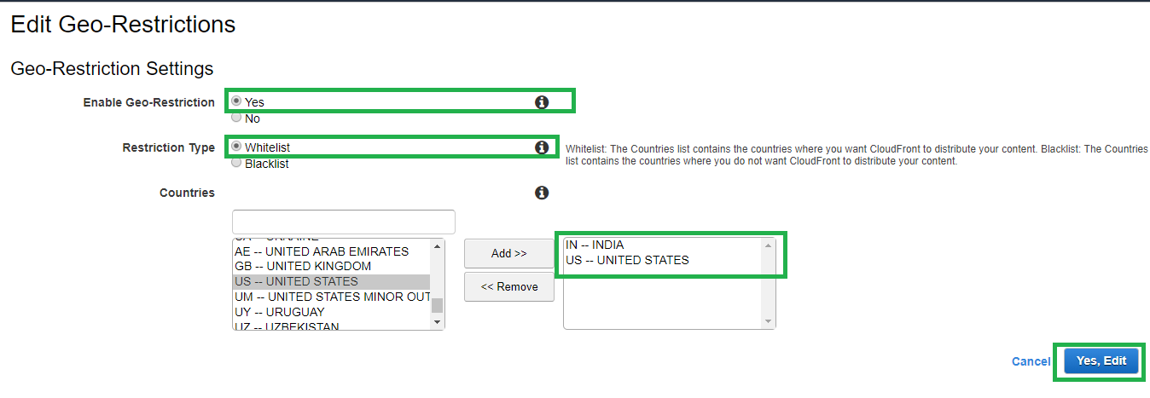

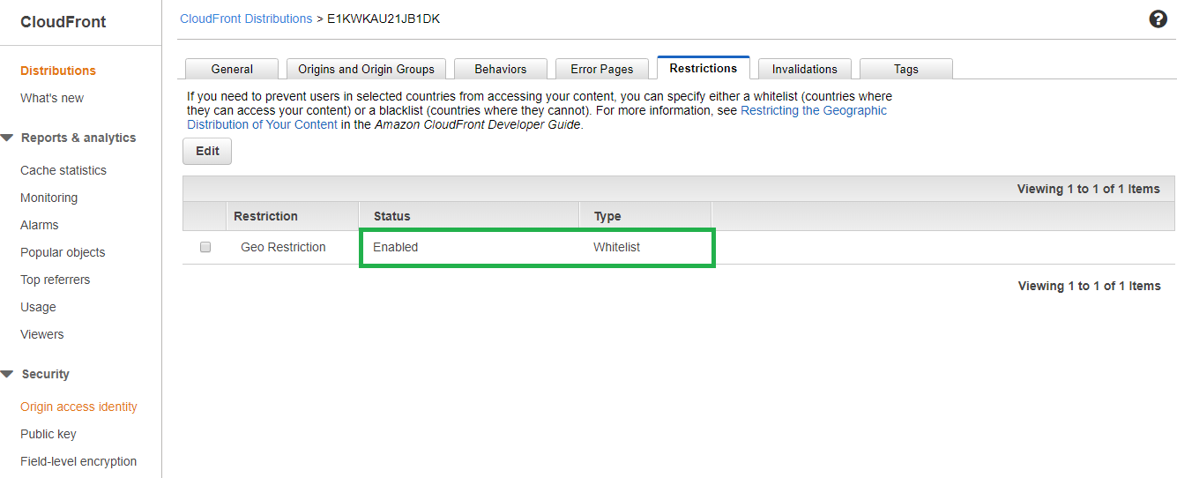

1. Verify the cloudfront requests are now going through and working fine as expected.

